
VENUE LAYOUT
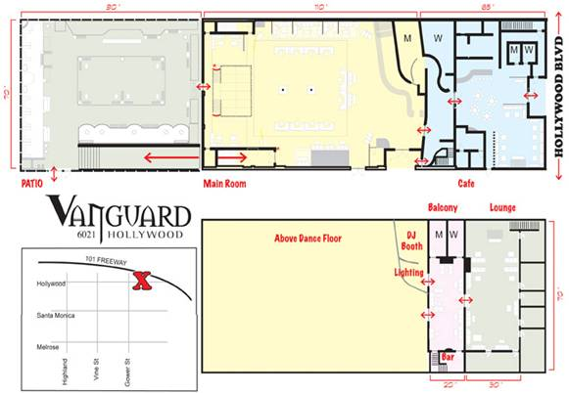
Lounge
Cafe
Balcony
Patio
Main Room

TECHNICAL SPECIFICATIONS
Lighting
- 130-LED Fixture (truss toners and washes)
- 28- ETC Source Four PAR Fixtures
- 13- Martin Professional Atomic 3000 Strobes
- 10- Robe Color Spot 250 AT Fixtures
- 8- Robe Wash 250 XT Fixtures
- 6- Robe Color Spot 170 AT Fixtures
- 4- ETC Source Four Fixtures
- 4- Robe Scan 250 XT Fixtures
- 1- MA Lighting grandma Lighting Console

Video
- 4- BenQ PB7210 Video Projectors
- 1- Toshiba SD-K750 DVD Players
- 1- Edirol DV-7PR Video Presenter (w/Edirol PCR-50 Midi Controller)
- 1- Edirol V-4 Video Mixer
- 1- Marshal VJ 563P Triple Display Monitor
Audio- Main Room
- 16- Funktion One F-218 Subwoofers
- 16- MC2 Audio E45 Amplifiers
- 10- MC2 Audio T-2000 Amplifiers
- 8- Funktion One Resolution 5 Speakers
- 4- Funktion One Resolution 4 Speakers
- 1- Turbosound TQ-310 Ceiling Speakers
DJ Booth
- 3- Biamp Nexia Digital Processors
- 3- Crest Pro 8001 Amplifiers
- 2- Custom 18-inch Subwoofers
- 2- Custom Monitors w/ JPL Hi/Mids and P Audio Compression Drivers
- 2- Pioneer CDJ-1000MK2 Digital Vinyl Turntables
- 2-Technics SL- 1200MK5 Turntables (w/Stanton Cartridges)
- 1- Allen & Heath Xone: 92 DJ Mixer

Audio- Upstairs
- 2-Turbosound TCS-56 Speakers
- 2-Turbosound QLight TQ 440SP Hi/Mids
- 2- Turbosound QLight 425 SP Subwoofers
- 1- Crest Pro 6001 Amplifier
Balcony
- 2- FBT MaxX 5A Active Monitors
- 2- Turbosound Qlight 425-SP Subwoofers

